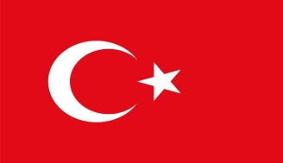

BUSINESS AND INVESTMENT OPPORTUNITIES IN BANGLADESH

10 JULY 2018
ISTANBUL
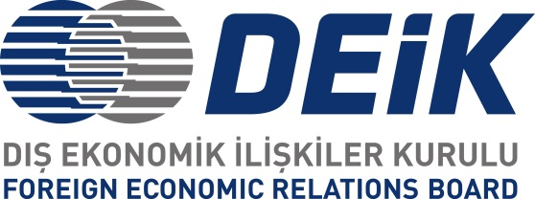

DRAFT PROGRAM

11.00 – 11.10 Welcome remarks by Ms. Laura Gok, Chairman of DEİK/ Turkey- Bangladesh Business Council

11.10 – 11.15 Video presentation on Bangladesh

11.15 – 11.25 Introductory Remarks by H. E. Mr. M. Allama Siddiki, Bangladesh Ambassador to Turkey

11.25 – 11.45 ‘Socio-economic Dynamics of Bangladesh: From Global Projection’ by Dr. Mohammad Monirul Islam, Consul General of Bangladesh in Istanbul

11.45 – 12.15 ‘Bangladesh – Turkey Bilateral Relations: Business and Investment holding the key’ by H. E. Mr. M. Allama Siddiki, Bangladesh Ambassador to Turkey

12.15 – 12.30 Sharing the experiences by the Turkish businessmen and investors
12.30 – 12.50 Questions/ Comments/ Observations from the audience

12.50 – 13.00 Closing remarks

13.00-14.00 Working Lunch hosted by H. E. Mr. M. Allama Siddiki, Bangladesh Ambassador to Turkey

